Module de commande de moteur pas à pas ULN2003
publication: 25 octobre 2020 / mis à jour 25 octobre 2020
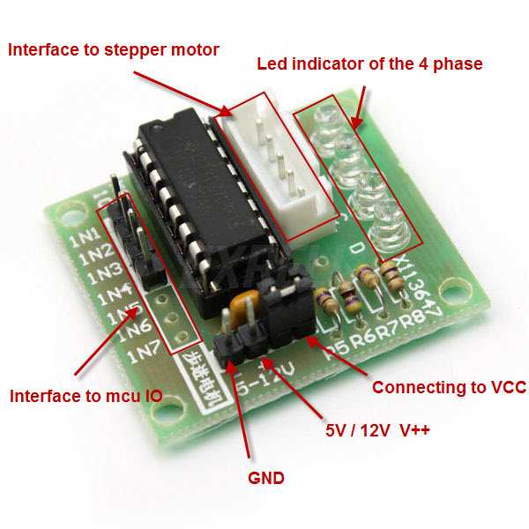

Caractéristiques
L'ULN2003 regroupe sur un même circuit intégré 7 transistors darlington, ce qui permet d'alimenter un moteur avec un courant beaucoup plus intense que ce que peut tolérer un microcontrôleur comme l'Arduino.
IMPORTANT: l'ULN2003 fonctionne très bien pour des moteurs pas à pas unipolaires (ceux qui sont munis de 5 ou 6 fils), mais il n'est pas du tout conçu pour piloter des moteurs pas à pas bipolaires (ceux qui ne comportent que 4 fils). Pour un moteur bipolaire, il faudra utiliser un autre circuit intégré, comme par exemple le L293D ou le L297.

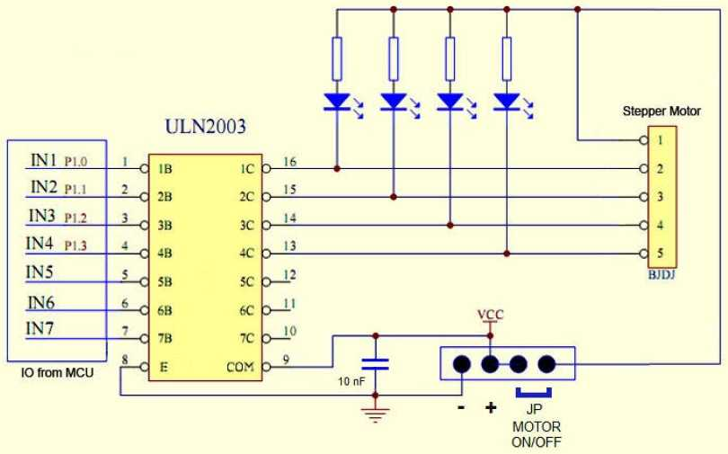
The ULN2003 stepper motor driver board allows you to easily control the 28BYJ-48 stepper motor from a microcontroller, like the Arduino Uno. One side of the board side has a 5 wire socket where the cable from the stepper motor hooks up and 4 LEDs to indicate which coil is currently powered. The motor cable only goes in one way, which always helps. UNL2003 board On the side you have a motor on / off jumper (keep it on to enable power to the stepper). The two pins below the 4 resistors, is where you provide power to the stepper. Note that powering the stepper from the 5 V rail of the Arduino is not recommended. A separate 5-12 V 1 Amp power supply or battery pack should be used, as the motor may drain more current than the microcontroller can handle and could potentially damage it. In the middle of the board we have the ULN2003 chip. At the bottom are the 4 control inputs that should be connected to four Arduino digital pins.

Hooking it up to the Arduino
Connect the ULN2003 driver IN1, IN2, IN3 and IN4 to digital pin 3, 4, 5 and 6 respectively on the Arduino Uno. Connect the positive lead from a decent 5-12V battery pack to the “+” pin of the ULN2003 driver and the ground to the “-” pin. Make sure that the “on/off” jumper next to the “-” pin is on. If you power the Arduino from a different battery pack, connect the grounds together.
https://forum.fritzing.org/t/28byj-48-stepper-motor-and-uln2003-driver-module/12883

https://www.instructables.com/3D-Printable-3D-Scanner-Using-Intel-Realsense-D435/

https://arduinogetstarted.com/tutorials/arduino-controls-28byj-48-stepper-motor-using-uln2003-driver

https://www.seeedstudio.com/blog/2019/03/04/driving-a-28byj-48-stepper-motor-with-a-uln2003-driver-board-and-arduino/

